|  |  |
| --- | --- |
| **Project: New Haven Urgent Care Team# 18** | |
|  | **Test Date: 12/11/2018** |
| **Test Case ID#:** 15 | **Name(s) of Tester(s):** Yiping Ren, Zhenyu Fan, |
| **Test Description (What are you testing? – you must be specific):**  Is there an accounting mechanism for the medical items used. We should be able to determine  what doctor annotated the billable supplies and items. The nurse is responsible for the accounting  to the doctor. |  |
|  |  |

**NOTE: The following information must be provided to be given credit for any test.**

**Test Data (Provide the file name of the script used to insert data, provide a screen capture to reflect data, or provide script here):**

Filename: test15.sql

|  |
| --- |
| SET SQL_SAFE_UPDATES = 0; |
|  | set foreign_key_checks=0; |
|  | DELETE FROM Bill; |
|  | DELETE FROM Equipment; |
|  | DELETE FROM Patient; |
|  | INSERT INTO Patient (PID, DATE_of_birth, Emergence_contact_info, Phone_number, 18_or_not, Address, Name, Assessment_Id) |
|  | VALUES (1, '2001-07-03', '(272)-375-3506', 123, 1, '9113 Highbrook Drive, Dunedin, Marlborough, 84498', 'Quinn Jackson', 1); |
|  | INSERT INTO Patient (PID, DATE_of_birth, Emergence_contact_info, Phone_number, 18_or_not, Address, Name, Assessment_Id) |
|  | VALUES (2, '2003-08-03', '(613)-554-3096', 124, 1, '8217 Fatih Sultan Mehmet Cd, Bolu, Bilecik, 85598', 'Louisa Gonzalez', 2); |
|  | INSERT INTO Patient (PID, DATE_of_birth, Emergence_contact_info, Phone_number, 18_or_not, Address, Name) |
|  | VALUES (3, '2005-07-11', '(283)-746-3029', 125, 1, '7485 Spring Hill Rd, West Valley, Kansas, 83498', 'Chad Hall'); |
|  | INSERT INTO Equipment (Item_identifing_ID, Name, Cost, Type) VALUES (756, "Gait Belts", 15, "Single Use"); |
|  | INSERT INTO Equipment (Item_identifing_ID, Name, Cost, Type) VALUES (354, "Armboard Strap", 5, "Reuseable"); |
|  | INSERT INTO Bill (Bill_id, PID, Used_item_ID, Dept_ID) VALUES (1, 1, 354, 1); |
|  | INSERT INTO Bill (Bill_id, PID, Used_item_ID, Dept_ID) VALUES (2, 2, 756, 1); |
|  | INSERT INTO Bill (Bill_id, PID, Used_item_ID, Dept_ID) VALUES (3, 3, 354, 2); |
|  | INSERT INTO Bill (Bill_id, PID, Used_item_ID, Dept_ID) VALUES (4, 1, 354, 1); |
|  | INSERT INTO Bill (Bill_id, PID, Used_item_ID, Dept_ID) VALUES (5, 1, 354, 1); |
|  | INSERT INTO Bill (Bill_id, PID, Used_item_ID, Dept_ID) VALUES (6, 3, 354, 3); |

Reflect data

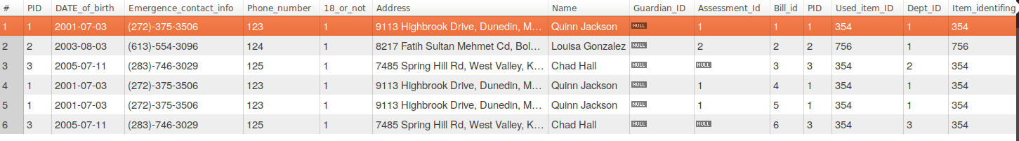

**SQL Query(s) used for testing:**

|  |
| --- |
| SELECT * FROM |
|  | Patient, Bill, Equipment |
|  | WHERE Patient.PID = Bill.PID AND |
|  | Bill.Used_Item_ID = Equipment.Item_identifing_ID; |
|  | SET foreign_key_checks=1; |
|  | SET SQL_SAFE_UPDATES = 1; |